|  |  |
| --- | --- |
|  | **SRI VENKATESWARA ENGINEERING COLLEGE**  Karakambadi Road, Tirupati - 517 507, A.P.  Accredited by NAAC, Approved by AICTE & Permanently Affiliated to JNTUA  Recognized under section 2(f) & 12 (B) of UGC act 1956. |

**DEPARTMENT OF ELECTRICAL & ELECTRONICS ENGINEERING**

CONSOLIDATED REPORT ON

**ALUMINI FEEDBACK ON CURRICULUM**

|  |  |  |  |  |  |  |  |  |
| --- | --- | --- | --- | --- | --- | --- | --- | --- |
| S.  No | Statements | **Excellent-5** | **Very Good-4** | **Good-3** | **Average-2** | **Below Average-1** | **Sum** | **%** |
| 1 | When you compare yourself with other counterparts from other institution, you feel that you got most of all the facilities which is not available in other institution | 10 | 8 | 2 |  |  | 88 | 88.00 |
| 2 | Learning value (In terms of skills, concepts, knowledge, analytical abilities or broadening perspective) | 10 | 7 | 3 |  |  | 87 | 87.00 |
| 3 | Curriculum is sufficient to make you analyze the engineering problems and its suitable solutions | 9 | 8 | 3 |  |  | 86 | 86.00 |
| 4 | How do you rate the learning experiences in terms of their relevance to the real life application | 11 | 8 | 1 |  |  | 90 | 90.00 |
| 5 | Ability to work in teams | 10 | 8 | 2 |  |  | 88 | 88.00 |
| 6 | Ability to link theory to practice | 12 | 6 | 2 |  |  | 90 | 90.00 |
| 7 | How do you rate the course/curriculum content that you have learnt in relation to your current job | 13 | 6 | 1 |  |  | 92 | 92.00 |
| 8 | Compatibility with industry standards | 10 | 8 | 2 |  |  | 88 | 88.00 |

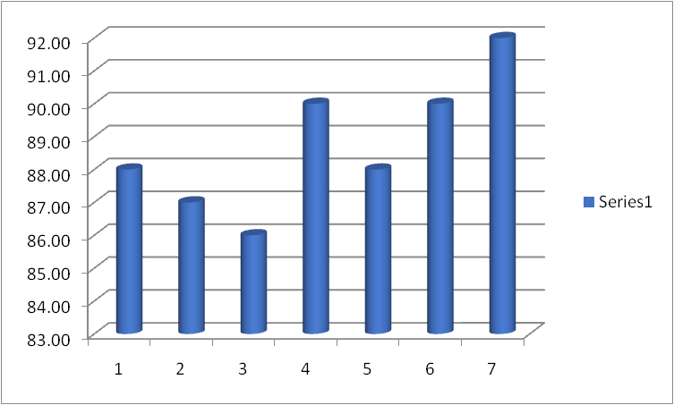

**HOD**